

Used Cars Price Analysis

ACKNOWLEDGMENT

I would like to express my sincere gratitude to the entire team at Analytics Space for providing me with the opportunity to work on the “Used Cars Price Analysis” project. My heartfelt thanks also extend to my academic mentors at Data Trained, whose continuous guidance enriched this learning journey. Engaging with this project deepened my understanding of data collection through web scraping and enhanced my skills in cleaning, manipulation, and advanced visualization. Analysing factors such as brand pricing, fuel types, and geographical trends across India offered me fresh perspectives and technical growth. This experience has been immensely valuable in sharpening my analytical abilities, and I am truly thankful for the insights, support, and constructive feedback that contributed to its successful completion.

CHAPTER 1

INTRODUCTION

Project Objective:
To perform a comprehensive analysis of used car listings across various regions in India by examining key factors such as car brand, fuel type, transmission, manufacture year, and location. The goal is to uncover pricing trends, identify best-value vehicles, and deliver actionable insights through visually engaging dashboards using Power BI. This project aims to help buyers make informed decisions by highlighting cars that offer the best quality-to-price ratio and brands that dominate specific markets.
Overview of Project:
This project involves multiple stages, including:
Web Scraping and Data Collection:
Extracting data on used cars, including brand, model, location, fuel type, transmission, driven kilometres, manufacture year, and price from trusted sources like CarDekho or CarWale. This raw data provides the foundation for analysing pricing and performance trends across different regions and brands.
Data Cleaning and Preprocessing:
Preparing the dataset for meaningful insights by addressing missing values, removing duplicates, and standardizing data formats—such as numeric conversions for price and consistent naming conventions across car brands and models.
Data Modelling and Analysis:
Applying statistical techniques and data modelling to uncover key patterns like price depreciation over time, brand popularity, regional price variations, and transmission or fuel type trends. Insights will be visualized through interactive dashboards in Power BI to assist buyers in identifying top-value vehicles.

Visualization
Presenting findings through interactive dashboards and compelling visualizations using Power BI to aid decision-making for car buyers, dealers, and automotive analysts. The dashboards highlight pricing trends, brand performance, and regional insights, enabling users to explore the data visually and identify value-driven choices with clarity and confidence.

1.2 Problem Statement
India's used car market is vast and diverse, with listings spanning multiple states, brands, fuel types, and price ranges. However, accessing structured, centralized, and comparative data on used car pricing remains a challenge for consumers and dealers alike. The lack of clearly organized information—such as regional price differences, vehicle condition, and brand depreciation—can hinder informed decision-making.
Without comprehensive insights into pricing patterns and value benchmarks, buyers may overpay for vehicles or overlook better options, while sellers may struggle to position cars competitively. Additionally, dealerships and market analysts often lack visual tools to identify trends that drive pricing and buyer preference across different regions.
This project addresses this gap by leveraging data analytics and interactive Power BI dashboards to analyse and visualize used car listings. Through this study, stakeholders will be equipped with meaningful insights into price drivers, regional market dynamics, and value optimization—enabling smarter, data-driven decisions for purchasing and selling used cars in India.
1.3 Project Objectives
The primary objective of this project is to analyse a dataset comprising detailed information about used cars listed across various Indian states. Through this analysis, the project aims to achieve the following specific objectives:
- Mapping Used Cars Across States: Compiling and analysing data on used car listings to understand the regional distribution and density of available vehicles, helping identify location-based pricing patterns and supply hotspots.
- Brand Popularity and Distribution Analysis: Evaluating the presence and frequency of different car brands across states to determine regional brand preferences, market share, and potential brand loyalty indicators.
- Price Structure and Depreciation Trends: Investigating car prices across models, manufacture years, and conditions to understand pricing tiers, depreciation behaviour and affordability differences between fuel types and transmission options.
- Fuel Type and Transmission Trends: Examining the spread of fuel types (petrol, diesel, CNG, electric) and transmission systems (manual vs. automatic) to highlight consumer preferences and their influence on pricing and resale potential.
- Value Assessment and Insight Generation: Identifying vehicles that offer the best quality-to-price ratio based on factors like brand reliability, driven kilometres, and age-enabling buyers to make smarter choices and sellers to optimize pricing.
By achieving these objectives, the project will provide actionable insights to assist buyers, dealers, and market analysts in navigating the used car ecosystem more effectively ensuring informed decisions and strategic sales or purchases.

CHAPTER 2
DATA COLLECTION AND SOURCES
Data Source
The primary data source for this project is CarDekho, a trusted online platform for automobile listings and market insights, especially within India's used car segment. CarDekho offers an extensive repository of pre-owned vehicle data across the country, covering details that are essential for pricing and value analysis.
The dataset utilized in this project captures used car listings from different states in India, enabling a rich, region-wise analysis of market trends and consumer preferences.
The dataset contains the following key variables:
- Location: The state where the car is listed, allowing for a geographical comparison of pricing and availability.
- Car Name and Brand: The model and brand of each vehicle, providing brand-level insights and identifying popular models across regions.
- Price (INR): The listed selling price of each car, used to analyse price ranges, affordability brackets, and depreciation trends.
- Fuel Type: Categories such as Petrol, Diesel, CNG, and Electric, enabling examination of fuel efficiency trends and preference shifts.
- Transmission Type: Indicates whether a car uses Manual or Automatic transmission, helping to assess its impact on pricing and buyer demand.
- KM Driven: The total distance the car has been driven, used for gauging wear-and-tear and its influence on resale value.
- Manufacture Year: The production year of the car, serving as a basis for analysing depreciation, usage lifecycle, and vintage demand.
This dataset serves as the foundation for uncovering price-related patterns, understanding buyer behaviour, and identifying factors that contribute to high or low market valuation—ultimately guiding users toward smarter and more informed decisions.

Web Scraping Process
Given the scale and diversity of data needed for analyzing used car listings across India, web scraping was adopted as the primary technique for extracting real-time vehicle data from platforms like CarDekho and CarWale. Python was chosen for this task due to its powerful suite of libraries designed for scalable and efficient data collection.
The following Python libraries were employed during the scraping process:
- BeautifulSoup: Used to parse HTML content and extract relevant details such as car brand, model name, location, price, fuel type, transmission type, kilometres driven, and manufacture year.
- Requests: Responsible for sending HTTP requests to the car listing websites and programmatically retrieving their HTML content for processing.
- Pandas: Utilized for organizing and cleaning the extracted data into structured Data Frames—facilitating further analysis, transformation, and visualization.

Steps in the Web Scraping Process:
- Sending Requests: HTTP requests were made to platforms like CarDekho and CarWale to access used car listings across various Indian states, covering details such as brand, model, price, fuel type, and transmission.

- Parsing HTML Content: BeautifulSoup was used to parse the retrieved HTML content, identifying relevant tags and attributes to extract structured data including car specifications, location, and price information.

- Extracting Data: The parsed data was organized into Pandas Data Frames, ensuring consistency across key variables like kilometres driven, manufacture year, and fuel type. This enabled smooth manipulation and analysis.

- Saving Data: The cleaned and structured dataset was saved in CSV format, ready for exploration and visual storytelling using tools like Power BI and Python-based analytics.

Challenges
Data Volume: Collecting listings from multiple states across India resulted in a large and diverse dataset. Efficient handling of regional variations, brand-specific records, and vehicle attributes demanded optimized data collection and processing techniques to maintain performance and accuracy.
Website Restrictions: Scraping from platforms like CarDekho and CarWale involved navigating barriers such as CAPTCHAs, rate limiting, and dynamically loaded JavaScript content. These were mitigated using strategies like request delays, randomized user-agent headers, and error-handling routines to ensure uninterrupted extraction.
Data Quality Issues: Inconsistencies such as incomplete records, varied brand/model naming conventions, and non-standard formatting of price fields required extensive cleaning and transformation. This step was crucial to ensure uniformity and reliability for downstream analysis and visualization.
Despite these challenges, the scraping process yielded a rich and well-structured dataset—empowering meaningful insights into pricing trends, brand dynamics, and consumer preferences in India's used car market.

CHAPTER 3
DATA PREPROCESSING

Effective data preprocessing is a critical step in ensuring the quality and reliability of the analysis. This stage involved cleaning the raw data collected via web scraping, transforming it into a structured format, and importing it into Power BI for interactive visualization. Below is a detailed breakdown of the steps undertaken:

DATA CLEANING:
The raw dataset included over 2500 used car listings spanning multiple states in India. While rich in detail, the data contained inconsistencies and formatting issues typical of web-scraped content. To ensure the dataset was clean and ready for analysis, the following steps were performed:
1. Removal of Duplicates:
Objective: Prevent inflated counts or distorted insights due to repeated listings.
- A total of 14 duplicate records were identified based on CAR NAME, MANUFACTURE YEAR, LOCATION, TRANSMISSION, and KM DRIVEN.
- These entries were removed using Python's drop_duplicates() to ensure each car was uniquely represented.
2. Handling Missing Values:
Status: No missing values were found.
- The dataset was complete across all major columns including FUEL TYPE, TRANSMISSION, PRICE (INR), and KM DRIVEN.
- No imputation or removal was necessary.

3. Column Standardization:
Purpose: Improve compatibility with Power BI and support consistent field names.
- Column headers were cleaned and reformatted to use underscores and uppercase lettering (e.g., CAR_NAME, PRICE_(INR), MANUFACTURE_YEAR).

This lightweight cleaning ensured the dataset was analysis-ready while preserving its original richness and detail. It allowed for a smooth transition into the data preprocessing and visualization phases without distortion or data loss.

CHAPTER 4
DATA ANALYSIS AND VISUALIZATION
4.1 Introduction
This chapter presents the analysis and visualization of used car market data in India, focusing on key attributes such as car brand distribution, fuel types, transmission systems, price ranges, and regional availability. The study uncovers insights into state-wise car listings, vehicle age-based price variations, and brand preferences, offering a clearer understanding of consumer behaviour and pricing dynamics across different regions.
4.2 Used Car Market Landscape: Dashboard Overview
This Power BI dashboard presents an interactive exploration of India's used car market using listings extracted through web scraping from CarsDekho. It offers insights into manufacturing trends, transmission and fuel preferences, brand-wise price distributions, and geographic availability. Each visualization aims to help buyers, sellers, and analysts make informed decisions backed by real-world data.
4.2.1 State-Wise Distribution Highlights:
- Top Region by Listings: Rajasthan records the highest number of used car listings, reflecting active resale activity in the region.
- Filters Provided: Users can slice the data by fuel type, transmission type, brand, and manufacture year to focus on targeted vehicle segments and market pockets.
4.2.2 Average Price by Manufacture Year:
- Trend Insight: The line graph highlights notable pricing peaks around
2020 and 2023, indicating strong resale retention for vehicles from those
years.
- Observed Price Range: Vehicle prices span from around ₹100,000 to
₹4.8 million, covering everything from compact hatchbacks to high-end
luxury SUVs.
4.2.3 Transmission-Based Analysis:
- Car Count Summary:
  - Automatic Cars: 108 listings
  - Manual Cars: 178 listings
- This indicates a clear preference for manual transmission in the current market, though automatic models have a solid presence, especially in premium and urban-oriented segments.
4.2.4 Fuel Type and Transmission Correlation:
- A bar chart breaks down pricing contribution across fuel types and transmission modes.
- Observations:
- Petrol vehicles dominate both in volume and value.
- Diesel comes next, followed by Electric and CNG, which account for smaller but emerging segments.
- Manual transmissions remain dominant across all fuel types, but automatic variants lead in higher-price brackets.
4.2.5 Brand-Wise Price Analysis:
- A pricing breakdown of premium models reveals strong market value concentration among luxury brands:
  - BMW XMxDrive (2024) leads with a combined listing value of ₹84 million.
  - Land Rover Defender models collectively account for ₹39.2 million.
  - Jaguar F-Pace Diesel contributes around ₹35 million.
- This table helps position premium listings for targeted buyer strategies.
4.3 Conclusion:
Based on the dashboard analysis of India’s used car market:
- Rajasthan emerges as the most active state for pre-owned vehicle listings, signalling a vibrant resale ecosystem.
- Petrol-powered cars continue to dominate, with Diesel, Electric, and CNG showing growing interest.
- Manual transmission vehicles make up the bulk of the listings, but Automatic cars retain strong pricing, especially among newer and luxury models.
- Premium brands such as BMW, Land Rover, and Jaguar are key contributors to cumulative price volume, indicating ongoing demand in the high-end market.
- Listings from 2020 and 2023 retain high price averages, suggesting favourable depreciation curves for recent models.
These insights empower consumers, sellers, and analysts to make data-driven decisions and uncover pricing patterns, inventory distribution, and preference trends across India’s dynamic pre-owned car landscape.

CHAPTER 5
TOOLS AND TECHNOLOGIES
Software Requirement: -
- Python (Jupyter notebook)
- Power bi
- Excel

Main Software Libraries: -
- Pandas
- Beautiful Soups
- Requests
- CSV

CHAPTER 6

DASHBOARDS

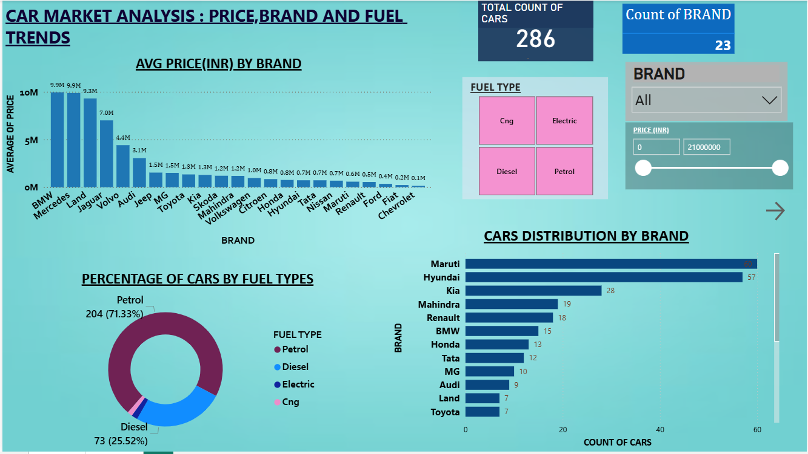

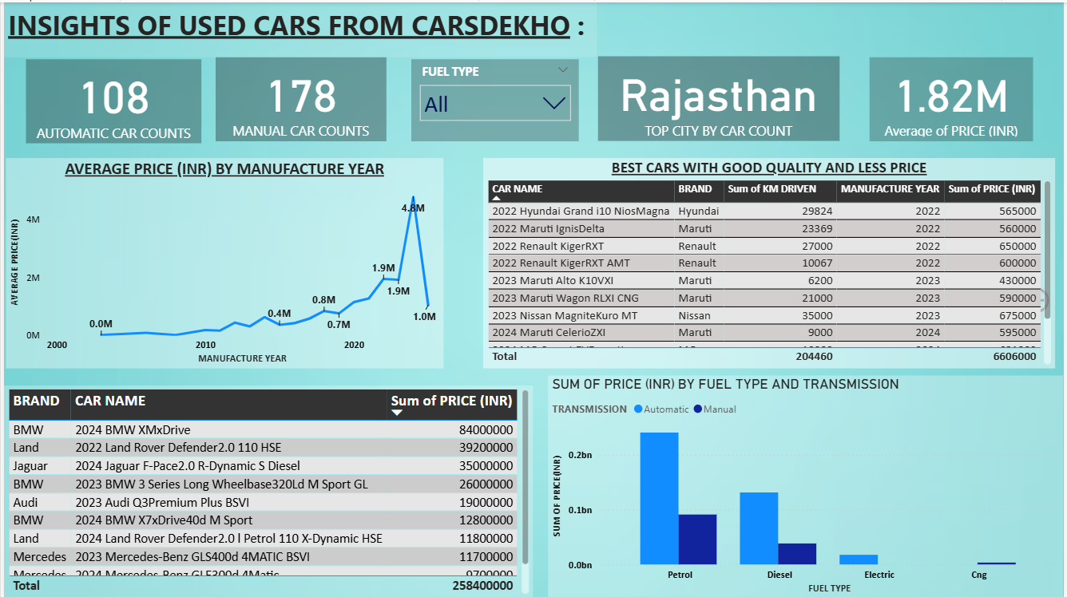

CHAPTER 7

CONCLUSION
Primary Objective
The goal of this analysis was to apply data analytics techniques to extract actionable insights from India’s used car market using scraped listings from CarsDekho. The dashboard explores key dimensions such as brand distribution, transmission preferences, fuel type trends, kilometre ranges, pricing patterns across manufacture years, and regional listing volume. By visualizing these attributes interactively, the project delivers a nuanced understanding of market behaviour—empowering users to assess vehicle value, buyer interest, and brand performance across diverse price segments and locations.
1. Car Listings Distribution and Availability
- Rajasthan records the highest concentration of used car listings, making it the most active regional market in the dataset.
- It’s followed closely by Tamil Nadu, West Bengal, and Madhya Pradesh, all of which show strong resale activity across a diverse range of car models.
- Other notable contributors include Karnataka, Uttar Pradesh, and Gujarat, each offering a sizeable share of the inventory.
2. Brand Popularity and Pricing Trends
Maruti, Renault, and Kia emerge as the most frequently listed brands across multiple states, reflecting their strong presence and affordability in India’s used car market.
- Premium brands like BMW, Jaguar, and Land Rover contribute significantly to overall pricing volume, underscoring their resale value despite fewer listings.
- The BMW XMxDrive stands out as the top contributor in cumulative price (₹84 million), followed by high-value entries like the Land Rover Defender and Jaguar F-Pace R-Dynamic Diesel—signalling a robust demand within the luxury resale segment.

3. Fuel Type and Transmission Preferences
Petrol vehicles clearly dominate the dataset in both volume and pricing value, reflecting their widespread acceptance in the Indian used car market.
- Diesel cars follow with strong representation, especially among SUVs and premium listings.
- Electric vehicles appear in modest numbers but show promising price tags, suggesting rising interest in sustainable mobility.
- CNG-powered cars remain a niche segment, with limited listings across states.
- Manual transmission is more common than Automatic, but automatic vehicles demonstrate higher pricing averages, especially among newer and luxury models—highlighting urban and premium buyer preferences.
4. Price Range and Manufacture Year Impact
- Price Distribution: The dataset reveals a wide pricing range—from affordable entries listed around ₹150,000 to luxury models exceeding ₹2.1 crore, such as the BMW XMxDrive.
- Manufacture Year Trends: Vehicles manufactured in 2023 and 2024 exhibit the highest average prices, showcasing strong market demand and slower depreciation for newer models.
- Older Listings: Cars from years before 2015 are consistently priced lower, validating expected depreciation curves and budget accessibility for older models.
- This dynamic allows buyers to balance price, age, and brand preferences while assessing value retention across various vehicle segments.

Implications for Stakeholders
Consumers (Buyers & Sellers)
- Buyers can identify the best deals by comparing fuel types, and brand value.
- Sellers can position their listings more competitively by analysing regional preferences and price brackets.
- Awareness of price drops in older models can inform negotiation strategies and resale timing.
Dealers & Aggregators
- Regional concentration insights help tailor inventory and marketing efforts.
- Understanding brand-specific resale strength aids stock decisions for trade-in programs.
- Transmission and fuel type analytics can guide future vehicle acquisition strategies.
Market Analysts & Platform Designers
- Valuable data for creating predictive pricing algorithms and dynamic recommendation systems.
- Helps in segmenting target users based on fuel preference, budget, and location.
- Insights into electric vehicle adoption trends may guide future platform features and content strategies.

Summary:
This analysis presents a data-driven approach to understanding the dynamics of India’s used car market. Insights from car brand distribution, fuel type trends, regional availability, and pricing across manufacture years offer key takeaways for buyers, sellers, and market analysts. Highlighting factors such as vehicle depreciation, transmission preferences, and regional pricing patterns allows stakeholders to navigate the second-hand automotive ecosystem with confidence.
By promoting transparency in price benchmarking, recognizing high-value models, and visualizing market segmentation across India, this project contributes to more informed, efficient, and consumer-aligned decision-making in the pre-owned car landscape.

